GWD-I | Miguel Esteban Gutiérrez, UPM
GGF DAIS Working Group | Asunción Gómez-Pérez, UPM
 | Isao Kojima, AIST
 | Said Mirza Pahlevi, AIST

Category: INFORMATIONAL July 28th, 2006
DAIS RDF(S) Realization: Background and Motivational Scenarios
Status of This Memo
This document provides information about the initiative for the provisioning of access to RDF(S) data resources by means of specific realizations of the WS-DAI Core specification.
Copyright Notice
Copyright © Global Grid Forum (2006). All Rights Reserved.
Abstract
The Database Access and Integration Services Working Group (DAIS-WG) has already submitted several specifications to the Global Grid Forum (GGF) recommendation track [WS-DAI, WS-DAIR, WS-DAIX]. These specifications provide a basic set of interfaces, properties and patterns for service-based data access within a grid. The core WS-DAI specification defines a set of common interfaces and properties that are independent of the type of underlying data resource, and provides a framework for extending this base specification with the messages and properties required to access specific types of data resource, e.g. relational or XML data resources which are covered by the WS-DAIR and WS-DAIX specifications respectively.
This document presents the background, motivational scenarios and a proposal to extend the DAIS charter to cover an RDF(S) access initiative within the DAIS-WG. This initiative is targeted at developing a suite of specifications that will define a standard mechanism for accessing RDF(S) data resources in a manner consistent with the framework defined by the WS-DAI core specification.
The main outcome of this work will be a set of specifications that provide complementary ways for accessing these types of resources: by means of ontological-based primitives or by means of the SPARQL query language.
Table of Contents
Abstract 1
1. Introduction 3
2. Background 3
2.1. Ongoing Research and Development Projects 3
2.1.1. Ontology Access in Grids 4
2.1.2. Semantic Service Oriented Architecture: AIST-SOA 4
2.2. GGF Database Access and Integration Services Working Group 5
2.3. W3C RDF Data Access Working Group 5
2.4. RDF Storage (Database) Systems 6
3. Motivational Scenarios 6
3.1. Ontology-based Access to RDF(S) Data Resources 6
3.2. Query-based Access to RDF(S) Data Resources 8
3.2.1. Semantic Matchmaking of Grid Resources using SPARQL 8
3.2.2. RDF Data Snapshot and View 8
3.2.3. Heterogeneous and Distributed Data Processing using OGSA-DAI Activity Framework 9
4. Roadmap 11
4.1. Specification Organization 11
4.2. Scope and Goals 11
4.3. Schedule 12
5. Conclusions 12
Author Information 12
Acknowledgements 13
Intellectual Property Statement 13
Full Copyright Notice 13
References 13

Introduction
Semantic technologies are increasingly being used nowadays, so much so that their level of use has reached a par with that of any other computer science related field, including grid computing. It is thus important that the next generation of grid technologies should be able to virtualise the notion of distributed computation, storage, and communication over unlimited resources with well defined semantics. A grid node may provide new services, functions, or even new concepts that are not known to clients. The semantics of such services and resources need to be defined by means of ontologies.
Ontologies could be used in the Grid for several purposes. As in the Semantic Grid projects described in the next section, some of these could be for: describing policies; sharing information, services and computing resources in virtual organizations; describing formal and non formal properties of grid resources and services; accessing data catalogues in a conceptual and multidimensional way; etc.
The Semantic Web community [SW] is currently leading the research and development work in semantic technologies. The main objective of the Semantic Web is the provision of a “common framework that allows data to be shared and reused across application, enterprise, and community boundaries” [SW W3C], building on the data model defined by the Resource Description Framework specifications [RDF, RDFS, RDF Semantics], also known as. RDF(S). RDF(S) provides a lightweight ontology system to support the exchange of knowledge on the Web.
An enormous amount of RDF(S) data has been created and stored in various applications and projects worldwide, and there is an increasing demand for accessing these RDF(S) data resources. Therefore, it is crucial to provide a standard, scalable and robust access mechanism to distributed RDF(S) data resources. A key to realizing this goal is to provide a standard RDF(S) data access functionality based on grid computing technology
The current OGSA architecture does not consider the use of RDF(S), and there are neither protocols nor standards available in the grid community for tackling this issue. Therefore, the provision of proven value mechanisms for accessing and managing RDF(S) in grid environments should be a top priority if the grid is to exploit the semantic technologies that are already available in other areas such as the Semantic Web.
This document describes the background and provides motivational scenarios illustrating the need for a set of service-based RDF(S)-accessing interfaces based on the GGF WS-DAI specification for data access and integration. The RDF(S) access suite of specifications is defined within the GGF activity to develop OGSA [OGSA] and its data architecture [OGSA-DATA]. Nevertheless, it can also be applied in the regular web services environment or as part of a grid fabric.

Background

Ongoing Research and Development Projects
There are many ongoing Semantic Grid projects worldwide. For instance, the European Union IST programme [IST] funds many Semantic Grid based projects, such as OntoGrid [ONTOGRID] and Intelligrid [INTELLIGRID]. The ^{my}Grid [MYGRID] and CombiChem [C-CHEM] projects are also examples of leading Semantic Grid projects based in the United Kingdom. Many information integration projects, like CaBIG [CABIG] and the Japanese NAREGI biogrid [BIOGRID] project use domain-specific ontology for their data grid applications. Many other Semantic Grid projects are listed on the website of the Semantic Grid Research Group [SEMRG].
These R&D projects handle a large number of ontologies, which can be written in an ontology language such as RDF(S) [RDF, RDFS] or OWL [OWL]. Simultaneously, the number of RDF instances are also increasing. Hence, there is a strong need for a standard grid-based interface to deal with the large amounts of RDF(S) data in the grid

Ontology Access in Grids
In the context of the OntoGrid project [ONTOGRID], the UPM (Universidad Politécnica de Madrid) is working in the provisioning of a grid based ontology access mechanism, which is to be consistent with the current OGSA architecture [OGSA], and is to be used as part of the S-OGSA architecture (the semantic extension of OGSA), which is also being developed within the same project [S-OGSA].
The work is mainly focused in providing a neutral ontology access mechanism, that is, a mechanism that is agnostic about the Knowledge Representation Formalism (KRF) that is used for developing the ontologies. A first draft of ongoing work can be found in [ONTOGRID D3.1].
The consortium has agreed on using RDF(S) [RDF, RDFS] as the KRF to be supported, and a preliminary prototype that allows the basic information about the taxonomy of a given ontology to be retrieved has been developed. The current documentation of the prototype can be found in [ONTOGRID D3.2].
The prototype, formerly named WS-DAIOnt-RDF(S), is being developed using the Globus Toolkit 4 Java WS Core grid infrastructure, and Sesame [SESAME] as the backend RDF(S) storage system.
The prototype has been designed to use a two layer architecture: on the one hand, the upper layer is responsible for the implementation of the grid service business logic; and on the other, the lower layer manages the interactions with the backend RDF(S) storage system. This architecture is targeted at decoupling the high level business logic of the RDF(S) access services (offered by a set of grid services) from the specific access to the RDF(S) storage systems used as the backend (i.e., Sesame, Jena [JENA], etc.). This has been achieved by an extra data access layer, namely RDFSConnector, which adapts the access to the repository according to the services requirements.
Up to now, the prototype is being upgraded to allow the use of multiple RDF(S) storages as backends for the services. In order to do this, a plugin system is being developed based on the RDFSConnector. This system will allow the deployment of ad-hoc plugins, each of which provides access to an specific RDF(S) source, that will be directly integrated in the system.

Semantic Service Oriented Architecture: AIST-SOA
The National Institute of Advanced Industrial Science and Technology, Japan (AIST) launched a project called AIST-SOA [AISTSOA] in 2005. One of the aims of this project is to develop a semantic SOA environment in the grid. As described in the OASIS discussion document [S-SOA], AIST-SOA provides an infrastructure intended to automate service discovery, negotiation, adaptation, composition, invocation, and monitoring, as well as a service interaction requiring data, protocol, and process mediation. In this infrastructure, RDF is a fundamental element intended to provide a formal description of data services, resources, and their ontologies. The data services can be distributed across multiple sites and form a single virtual data service under OGSA.
As part of the AIST-SOA project, the following are on-going RDF-related research topics:
- S-MDS [SMDS]: The Semantic Resource Monitoring and Discovery System (MDS) describes grid resources and services using ontologies and provides discovery and monitoring functions using the RDF query languages SPARQL and RDQL [RDQL].
- Semantic Matchmaker [MATCH]: A SPARQL-based service and resource matchmaking system.
- RDFCube [RDFCube]: A three-dimensional hash indexing scheme for RDF query processing over a P2P environment. It provides efficient, scalable distributed RDF-based query join processing.
- OGSA-DAI-RDF [OGSADAIRDF]: A set of OGSA-DAI [OGSADAI] activities for RDF data access and processing that supports the SPARQL [SPARQL] query language and RDF(S) ontology.

More specifically, 1) and 2) are used for semantic resource discovery and selection within the semantic SOA and 2) and 3) provide scalable, robust access to distributed RDF databases. Note that all these research topics are based on the use of the RDF query language.

GGF Database Access and Integration Services Working Group
As described in the previous section, many Semantic Grid applications require standard access interfaces to a large number of RDF(S) data resources. Also, providing a scalable RDF(S) data access functionality in a distributed environment should be achieved using grid computing technology.
In GGF, The Database Access and Integration Working Group (DAIS-WG) is discussing service-based data access protocols for various types of data resource [WS-DAI, WS-DAIR, and WS-DAIX]. For instance, the WS-DAIX [WS-DAIX] specification realizes the access interface for XML databases. It allows a consumer to access an XML data resource using W3C XML query language standards, such as Xpath [XPATH] and XQuery [XQUERY]. The relational database realization WS-DAIR [WS-DAIR] realizes the access interfaces for relational databases and allows a consumer to access data resources using the ISO/IEC standard query language SQL [SQL] and to accept results in the WebRowSet result format [JSR114].
These realizations extend the interfaces defined in the WS-DAI core specification [WS-DAI]. This base specification defines the base operations, properties, access patterns, and resource model that are common to service based access to data resources. Currently, three documents (WS-DAI, WS-DAIR, and WS-DAIX) are in the process of becoming GGF recommendations. Interoperability testing for WS-DAI, WS-DAIX, and WS-DAIR is currently in progress involving several implementations, including an OGSA-DAI-based implementation.
The architecture of the specification provides a clean approach to support new types of data resource, such as object-oriented databases, and files. Supporting a new data resource type within the WS-DAI framework is realized by defining the resource-specific operations and properties that extend those defined in the WS-DAI document. Support for RDF(S) data access in the grid should be based on this WS-DAI specification framework.
GGF requires two reference implementations in order for a specification to become a recommendation. WS-DAIOnt-RDF(S) and OGSA-DAI-RDF described in the previous sections are two potential implementation candidates that could be used for the WS-DAI RDF(S) realization.

W3C RDF Data Access Working Group
Currently, the W3C RDF Data Access Working Group (DAWG) is discussing a formal specification and use cases for an RDF query language. The working group has published the following working drafts:
1) RDF Data Access Use Cases and Requirements [UNCR]
2) SPARQL Query Language for RDF [SPARQL]
3) SPARQL Query Results XML Format [RESULTS]
4) SPARQL Protocol for RDF [SPROT]
The first document has been published as a working draft while the others are currently candidate recommendations. In a manner similar to the approach taken by WS-DAIR and WS-DAIX, the RDF(S) realizations need to take into account these W3C standards.
It is important to note that this set of W3C specifications are targeted at extracting data from RDF(S) repositories. That is, they currently do not define a means for creating, updating or deleting RDF(S) data such as [RDFNET]. Also, note that [SPROT] specifies the access protocol for SPARQL and it has functional overlap with the WS-DAI access protocol. However, the core model of WS-DAI has several functionailities specially defined for grid computing such as indirect data access by means of the factory pattern.

RDF Storage (Database) Systems
Many RDF storage systems are currently available. These include the popular Sesame and Jena RDF stores that provide SeRQL [SeRQL] and RDQL [RDQL], respectively, as their RDF query language.
With the progress in the W3C DAWG activity, many RDF storage systems including Sesame and Jena have started to support SPARQL to achieve interoperability among these systems. Several SPARQL query engines have emerged [ENGINES]. These include rasqual [RASQUAL], sparql-p [SPARQLP], and rap [RAP]. Although SPARQL does not deal with RDF data updates, some repositories provide basic RDF data update capabilities, such as RDF triples creation and deletion.
With the growth in the amount of RDF data and applications, several commercial RDF storage systems have emerged including Oracle [ORA10G], AllegroGraph [AG], and @semantics [AS]. These commercial products can reliably and efficiently store and manage very large amounts of RDF data.
We believe that providing a standard SPARQL query language interface for RDF data resources within the grid will have a significant impact on both semantic web and grid applications and general data grid computing.

Motivational Scenarios

Ontology-based Access to RDF(S) Data Resources
The RDF(S) specifications provide a lightweight ontology system specifically designed to support the exchange of knowledge about resources in the web, which has superseded the original application scope: up to now RDF(S) has been used in any area where metadata is needed or where the data that is to be used must be semantically defined.
RDF(S) is one of the base languages which the Semantic Web relies on: RDF Schema (and also OWL) is used for defining the ontologies that define how the knowledge about the world is structured, and RDF is used for expressing this specific information about the individuals in a standard way so that it can be exchanged between applications without the loss of any meaning.
In order to fully exploit the potential of these two languages it is necessary to provide an access mechanism which exposes all of the characteristics and capabilities of the model, and this mechanism should follow an ontological approach. As we said before, both specifications rely on the notion of ontology, therefore delivering functionalities that provide access in an ontological fashion (for instance making use of the taxonomical relationships between classes and properties) which is the most suitable way of ensuring a meaningful way of interacting with the RDF(S) resources.
The operations to be provided, which can be called ontology access primitives, must fulfil some minimum requirements:
- The operations must be simple, that is, the operations do not imply sequences of atomic operations.
- The operations must be common, that is, the operations which are used by almost every RDF(S)-based tool for interacting with the model.
- The operations must occur frequently, that is, the operations are frequently used in RDF(S)-based tools when interacting with the model.
A requirement for this set of operations is that, with the operations in the set, we must be able to create, delete, update and retrieve the contents of both the schema of the ontology and the instances defined according to that schema.
A sample scenario would be as depicted in Figure 1. In this scenario several different RDF(S) resources are deployed in a virtual organization. Each RDF(S) data resource uses a different RDF(S) storage system (Sesame, Jena, Oracle …). One of the data resources contains information about computer parts, i.e. motherboards, processors, etc. Another data resource contains information about manufacturers (Intel, AMD, …) and the other contains information about known dealers.
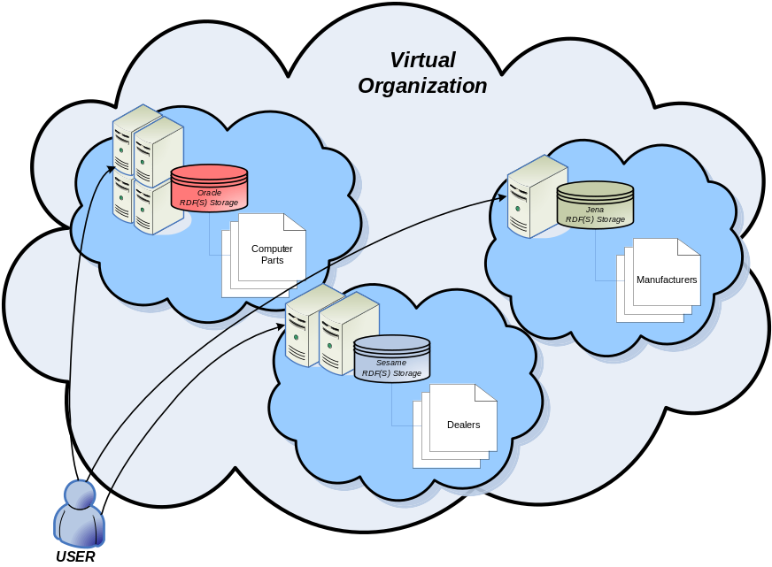
Figure 1. A sample virtual organization
Now, imagine that a user wants to create a company for selling custom-made computers. The user would use all the RDF(S) resources available in the virtual organization for organizing their back-office. Some of the functionalities needed for this would be, for instance, checking out which classes of computer parts exist; which manufacturer builds each of these; which dealers sell parts from a given manufacturer, etc.
In this scenario our user has a problem: there is no standard protocol for accessing the RDF(S) resources. Therefore, this user would need to know the specific APIs of the RDF(S) storage systems that need be used. In this scenario, the user would have to use the Sesame API for accessing the information about the dealers, Jena to access the information about the manufacturers and Oracle for retrieving the information about the computer parts. The more storage systems that are used, the more APIs that need to be know and hence the greater the effort that is required to build the back-office system. At the same time, migrating an ontology from one storage system to another would imply changing all the business logic that deals with the ontology, as a different API would have to be used.
Regardless of the specific API that the user has to use, a very limited (but well defined) set of operations over the model can be made. These operations can be grouped in two sets:
- The first contains the operations that allow work on the model, that is, to find out which is the structure of the underlying ontology and to modify it, i.e., browsing the taxonomy of the classes and properties, examining the properties defined for a given class, creating new classes, defining new properties, etc.
- The second contains the operations that act over the instances, that is, the data defined according the ontology: creating individuals of a specific class, defining the values of an specific property for a concrete individual, etc.
All of these operations can be seen as a set of pre-canned queries that can be made to the model, queries that are frequently used in ontology-based systems. The most important characteristic of all of these is that they are domain independent; therefore they can be reused in any context.

Query-based Access to RDF(S) Data Resources
W3C has already published a use case document [UNCR] for an RDF query language. The document gives various use cases that the query language must support. Some of the use cases can also be applied to Semantic Grid applications. In addition to these use cases, this section gives several motivational use cases for which WS-DAI specifications are considered suitable.

Semantic Matchmaking of Grid Resources using SPARQL
The grid includes a large number of resources with different capabilities distributed across different organizations. To discover and select target resources efficiently and accurately, several works have proposed describing grid resources and services semantically using RDF(S) and OWL [S-MDS] [OMM].
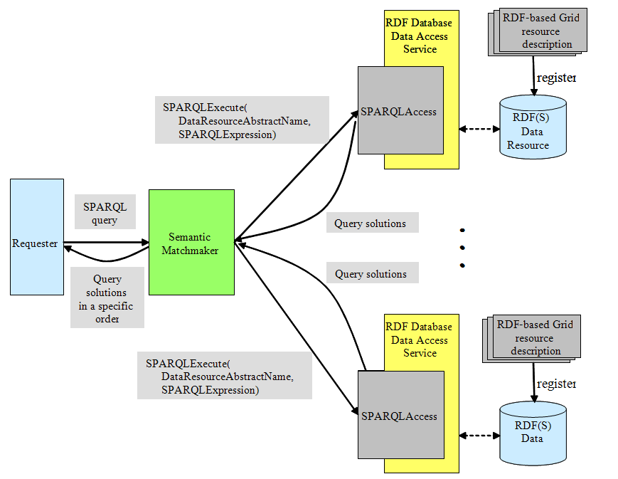
Figure 2. Semantic matchmaking using SPARQL
Given repositories that store resources and services with their semantic descriptions, the goal here is to query the resources and services using a high-level RDF query language, SPARQL, and order the matched resources based on a specific ordering criteria (e.g., class subsumption). Figure 2 presents a (possible) system architecture based on the WS-DAI specification for semantic matchmaking of grid resources using SPARQL. An RDF data resource sits behind a data access service that provides an interface to access the data resource. A requester sends a SPARQL query as a resource request to a matchmaker and the matchmaker forwards the query to one or more repositories. On receiving query results, the matchmaker orders the results based on class subsumption relationships and forwards the results to the requester. Similar work has been proposed and implemented in a semantic web environment [MATCH].

RDF Data Snapshot and View
RDF data/graph, such as data that describe the state of dynamic grid resources (e.g., processor load and available memory) [S-MDS], road traffic [TRAFFIC], and weather information, may change frequently. Providing a snapshot for such RDF data at a point in time may greatly help users in analyzing and processing data. Figure 3 shows a possible scenario, based on the WS-DAI specification, that would provide an RDF data snapshot and view.
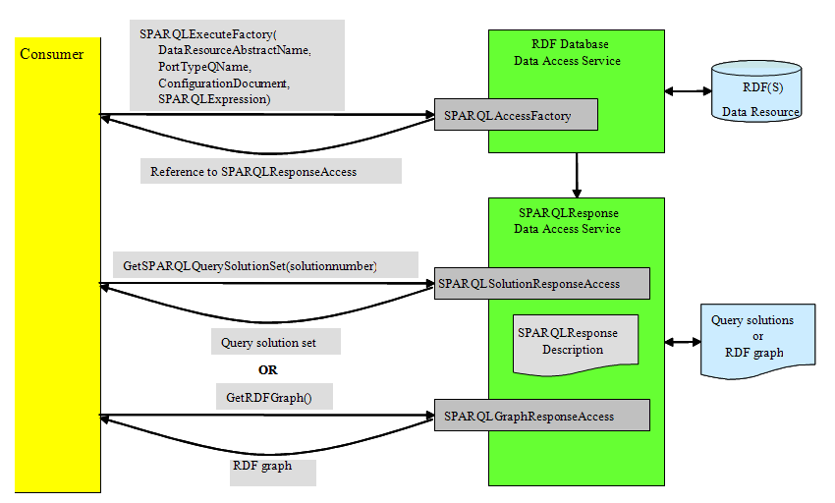
Figure 3. SPARQL query processing to get an RDF data snapshot
This scenario includes a SPARQLExecuteFactory operation with the WS-DAI Core Data Factory Messages. The SPARQLExecuteFactory operation is used to construct the SPARQLResponse Data Access Service. When a consumer sends a SPARQL expression with selected variables, the data resource of the SPARQLResponse data access service is a set of query solutions. By contrast, when the query is a SPARQL expression that constructs a new RDF graph, the data resource is an RDF graph. The SPARQLResponse Data Access Service provides two interfaces, the SPARQLSolutionResponseAccess and SPARQLGraphResponseAccess, to access the two types of data.

Heterogeneous and Distributed Data Processing using OGSA-DAI Activity Framework
As described in Section 2.1.2, AIST is developing a set of OGSA-DAI activities for handling RDF data. The current OGSA-DAI-RDF [OGSADAIRDF] provides the following functionalities:
- sparqlQueryStatement activity to query RDF data/graph using SPARQL.
- rdfResourceManagement activity to insert/delete RDF data/graph.
- rdf CollectionManagement activity to manage RDF data resources.
- rdfBulkload activity to load RDF data into an RDF data resource.
- rdfSchema activity to provide accessing RDF(S) ontology, which is based on [ONTOGRID D3.1].
- rdfInstance activity to provide accessing RDF(S) ontology instances.
The RDF activities including the existing OGSA-DAI activities are shown in Figure 4.
RDF activities can be combined with other OGSA-DAI activities, such as a relational database, XML database, data transfer, and conversion activities to perform complex RDF data processing. Examples include:
- Distributed RDF data processing that combines RDF activities with data transfer, conversion, and compression activities.
- Data integration over heterogeneous data resources that combines RDF activities with relational or XML database processing activities.
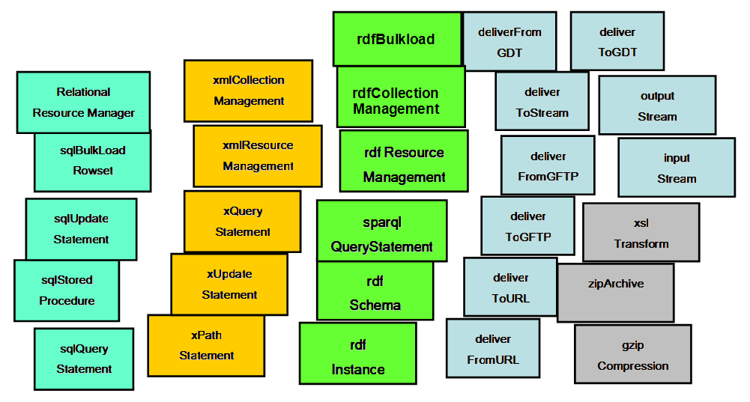
Figure 4. OGSA-DAI activities including RDF processing activities
Figure 5 shows simple distributed RDF data processing over two OGSA-DAI data services. In this example, the results of a sparqlQueryStatement activity are converted into RDF format using xslTransform activity at Service 1. Then, Service 1 sends the converted data to Service 2, which is located at a different site, using deliverToGDT activity. On receiving the data, Service 2 creates an RDF collection using rdfCollectionManagement activity. The data is stored in the collection using a rdfResourceManagement activity and it can be further accessed by another sparqlQueryStatement activity. This activity workflow can be carried out using two OGSA-DAI perform documents.
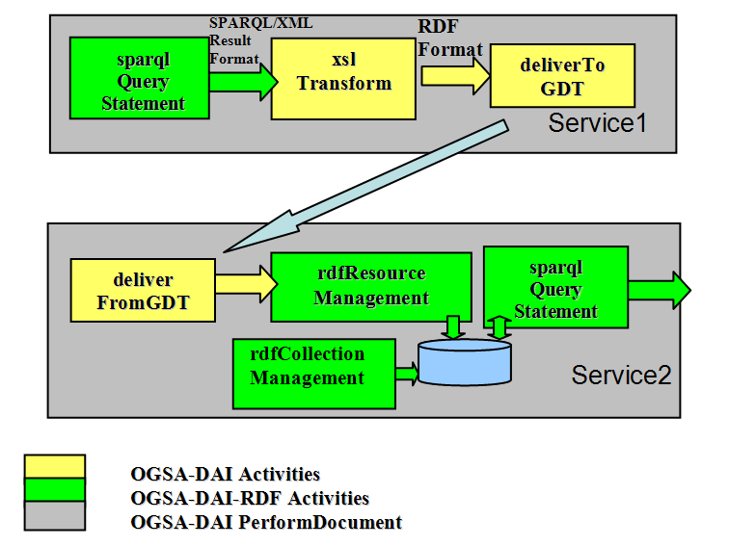
Figure 5. Distributed RDF Data Processing using OGSA-DAI-RDF Activities
This example demonstrates that cooperation between RDF activities and other data grid activities is easily achieved by defining standard interfaces for RDF data access and operation.
Another example is a data integration application based on a given ontology. Many data integration applications store their data in relational databases and manage a set of metadata describing the contents and structures of the database using RDF(S) or OWL.
This framework can be applied in this environment to facilitate data access and integration. For example, a client first retrieves the metadata of the database based on specific criteria using sparqlQueryStatement activity. Then, the client identifies target databases, formulates SQL queries, and finally sends the queries using sqlSelectStatement activity.

Roadmap

Specification Organization
The purpose of this initiative is to provide access to RDF(S) data resources in the grid and the data access and integration facilities defined in the WS-DAI Core specification.
An RDF(S) data resource (RDF(S) data) is a data source/sink that is based on the RDF(S) data model, together with any associated management infrastructure. The examples are RDF(S) repositories, RDF/XML files, systems with an RDF(S)-based data model.
At the present time, we have identified two different ways of interacting with this kind of resources: following an ontological approach that enables the user to explore and modify the resource using ontological access primitives; and following a query approach, in which the user can retrieve the contents of the resource using custom-made queries. The common denominator of both approaches is the type of underlying data resource and the data model managed by the data resource.
Both approaches are not exclusive, as using one of them does not imply that the other one cannot be used at the same time on the same resource. Furthermore, they are complementary, as they offer different mechanisms for interacting with the data resources, each one of them targeted to fulfil specific access requirements.
As we have said, each approach provides a different way for dealing with the resources therefore they need to be addressed in different specifications. Nevertheless, both specifications should not be totally decoupled, as they share their principal actor: the RDF(S) resource. Therefore, this shared element has to be agreed by both specifications, thus we can achieve true interoperability between them.
Figure 6 shows how these two specifications are related, and how are they related to the other existing WS-DAI realizations. Both the RDF(S) Ontology and Query access specifications are WS-DAI realizations, like WS-DAIR and WS-DAIX, but they have a common base, WS-DAI-RDF(S) which defines, using the WS-DAI terminology, all those concepts that are common to both specifications and the vocabulary that is to be used in both specifications. Following this approach if any other RDF(S) access mechanism is proposed in the future could be “plugged” to the architecture and still would still be interoperable with the previous versions.
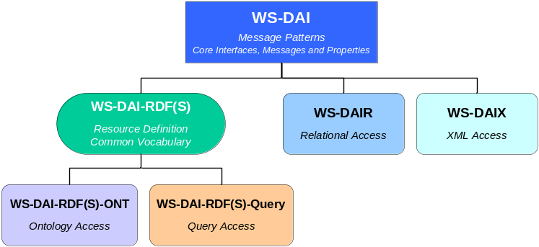
Figure 6. Specification organization

Scope and Goals
The following scope and goals are proposed to be included in the current DAIS-WG charter.
Scope: Setting RDF(S) access specifications, based on the existing WS-DAI specifications, which are defined by the DAIS-WG.
Goals: The following documents will be added to the current DAIS goals and milestones.
- DAIS for RDF(S) Realizations: Background and Motivational Scenarios (this document): This document includes the background, motivational examples, and proposal for WS-DAI RDF Realization.
- Data Service Specification: RDF(S) Querying: The document presents the WS-DAI specification for RDF(S) Querying based on the set of W3C SPARQL specifications. This provides the query language function for RDF data.
- Data Service Specification: RDF(S) Ontology Access: This document shows how the WS-DAI ontology is handled based on RDF(S). This specification supports various operations, including updates to the ontology.

Schedule
July 2006: Informational Document for DAIS of the RDF(S) Realizations.
September 2006: First straw man documents for both specifications.
March 2007: Initial draft of the RDF(S) access specifications, which is consistent with WS-DAI and the OGSA data architecture.
August 2007: Revised draft of the RDF(S) access specifications, to enter the process of standardization.

Conclusions
The provisioning of RDF(S) access mechanisms for OGSA is of major interest to the community as it will be the first step in the way for enhancing the current grid by means of semantic technologies.
The DAIS WG is about to start an initiative for providing such mechanisms as part of the data access and integration facilities that are being defined at the moment. The work will be carried out in parallel: one focused on accessing following an ontological approach, and the other targeted at accessing to RDF(S) contents using the query language.
The work that is to be accomplished has its roots is previous work undertaken by the AIST and the OntoGrid project, teams who will keep working in these issues and will lead the initiative.
Nevertheless, we encourage to the rest of the DAIS WG members and other GGF members who are interested in the forthcoming work, to join the initiative.
Author Information
Miguel Esteban Gutiérrez
Ontology Engineering Group (OEG),
Universidad Politécnica de Madrid (UPM),
Campus de Montegancedo s/n,
28660 – Boadilla del Monte, Madrid
Spain

Asunción Gómez-Pérez
Ontology Engineering Group (OEG),
Universidad Politécnica de Madrid (UPM),
Campus de Montegancedo s/n,
28660 – Boadilla del Monte, Madrid
Spain

Isao Kojima
Grid Technology Research Center
National Institute of Advanced Industrial Science and Technology (AIST)
Central 2, 1-1-1 Umezono, Tsukuba, Ibaraki
305-8568 Japan

Said Mirza Pahlevi
Grid Technology Research Center
National Institute of Advanced Industrial Science and Technology (AIST)
Central 2, 1-1-1 Umezono, Tsukuba, Ibaraki
305-8568 Japan
Acknowledgements
We would like to thank to those members of the DAIS-WG who have helped us in the process of chartering the initiative as part of the DAIS WG: Mario Antonioletti, Malcolm Atkinson, Amy Krause, Norman W Paton and Dave Pearson.
We also have to thank to the AIST and the OntoGrid project, as their funding has made possible this work.
Intellectual Property Statement
The GGF takes no position regarding the validity or scope of any intellectual property or other rights that might be claimed to pertain to the implementation or use of the technology described in this document or the extent to which any license under such rights might or might not be available; neither does it represent that it has made any effort to identify any such rights. Copies of claims of rights made available for publication and any assurances of licenses to be made available, or the result of an attempt made to obtain a general license or permission for the use of such proprietary rights by implementers or users of this specification can be obtained from the GGF Secretariat.
The GGF invites any interested party to bring to its attention any copyrights, patents or patent applications, or other proprietary rights which may cover technology that may be required to practice this recommendation. Please address the information to the GGF Executive Director.
Full Copyright Notice
Copyright (C) Global Grid Forum (2006). All Rights Reserved.
This document and translations of it may be copied and furnished to others, and derivative works that comment on or otherwise explain it or assist in its implementation may be prepared, copied, published and distributed, in whole or in part, without restriction of any kind, provided that the above copyright notice and this paragraph are included on all such copies and derivative works. However, this document itself may not be modified in any way, such as by removing the copyright notice or references to the GGF or other organizations, except as needed for the purpose of developing Grid Recommendations in which case the procedures for copyrights defined in the GGF Document process must be followed, or as required to translate it into languages other than English.
The limited permissions granted above are perpetual and will not be revoked by the GGF or its successors or assigns.
This document and the information contained herein is provided on an "AS IS" basis and THE GLOBAL GRID FORUM DISCLAIMS ALL WARRANTIES, EXPRESS OR IMPLIED, INCLUDING BUT NOT LIMITED TO ANY WARRANTY THAT THE USE OF THE INFORMATION HEREIN WILL NOT INFRINGE ANY RIGHTS OR ANY IMPLIED WARRANTIES OF MERCHANTABILITY OR FITNESS FOR A PARTICULAR PURPOSE."
References
[GFD.1]
C. Catlett, GGF Document Series, Global Grid Forum Document GFD.1
[WS-DAI]
M. Antonioletti, M. Atkinson, A. Krause, S. Malaika, S. Laws, N. W. Paton D. Pearson, and G. Riccardi. Web Services Data Access and Integration – The Core (WS-DAI) Specification, Version 1.0. GWD-R, Global Grid Forum, DAIS Working Group, Jun 2006.
[WS-DAIR]
M. Antonioletti, B. Collins, A. Krause, S. Laws, J. Magowan, S. Malaika, and N.W. Paton. Web Services Data Access and Integration – The Relational Realisation (WS-DAIR) Specification, Version 1.0. GWD-R, Global Grid Forum, DAISWorking Group, Jun 2006.
[WS-DAIX]
M. Antonioletti, S. Hastings, A. Krause, S. Langella, S. Laws, S. Malaika, and N.W. Paton. Web Services Data Access and Integration – The XML Realization (WS-DAIX) Specification,Version 1.0. GWD-R,Global Grid Forum,DAISWorking Group, Jun 2006.
[OGSA]
I. Foster (Ed), D. Berry, A. Djaoui, A. Grimshaw, H. Kishimoto (Ed) B. Horn, F. Maciel, A. Savva (Ed), F. Siebenlist, R. Subramaniam, J. Treadwell, and J. Von Reich. The Open Grid Services Architecture, Version 1.5. GWD-I, Global Grid Forum, OGSA Working Group, Mar 2006.
[XPATH]
J. Clark and S. DeRose. XML Path Language (XPath), Version 1.0. W3C Recommendation 16 November 1999.
http://www.w3.org/TR/xpath.
[XQUERY]
S. Boag, D. Chamberlin, M. F. Fernández, D. Florescu, J. Robie and J. Siméon. XQuery 1.0: An XML Query Language, W3C Candidate Recommendation 8 June 2006.
http://www.w3.org/TR/2006/CR-xquery-20060608/
[JSR114]
J. Bruce, JSR-000114 JDBC RowSet Implementations, Final Release, 07 April 2004.
http://jcp.org/aboutJava/communityprocess/final/jsr114/index.html.
[SQL]
Information technology -- Database languages -- SQL -- Part 14: XML-Related Specifications (SQL/XML), ISO/IEC 9075-14:2003,
http://www.iso.ch/iso/en/stdsdevelopment/tc/tclist/TechnicalCommitteeStandardsListPage.TechnicalCommitteeStandardsList?COMMID=160&printable=true.
[RDF]
Resource Description Framework (RDF)
http://www.w3.org/RDF/
[RDFS]
Dan Brickley and R.V.Guha, RDF Vocabulary Description Language 1.0: RDF Schema. W3C Recommendation 10 February 2004
http://www.w3.org/TR/2004/REC-rdf-schema-20040210/
[RDF Semantics]
P. Hayes (Ed). RDF Semantics. W3C Recommendation 10 February 2004
http://www.w3.org/TR/rdf-mt/
[OWL]
Peter F. Patel-Schneider, Patrick Hayes and Ian Horrocks, OWL Web Ontology Language Semantics and Abstract Syntax W3C Recommendation 10 February 2004
http://www.w3.org/TR/2004/REC-owl-semantics-20040210/
[SPARQL]
Eric Prud'hommeaux and Andy Seaborne. SPARQL Query Language for RDF, W3C Candidate Recommendation 6 April 2006
http://www.w3.org/TR/2006/CR-rdf-sparql-query-20060406/.
[RESULTS]
D. Beckett, SPARQL Query Results XML Format, W3C Candidate Recommendation 6 April 2006.
http://www.w3.org/TR/2006/CR-rdf-sparql-XMLres-20060406/.
[SPROT]
K. Clark, SPARQL Protocol for RDF, W3C Candidate Recommendation 6 April 2006.
http://www.w3.org/TR/2006/CR-rdf-sparql-protocol-20060406/
[UCNR]
K. Clark, RDF Data Access Use Cases and Requirements , W3C Working Draft, last release 25 March 2005,
http://www.w3.org/TR/2005/WD-rdf-dawg-uc-20050325/
[SW]
T. Berners-Lee, J. Hendler, O. Lassila. The Semantic Web. Scientific American, 284(5) (2001) 34 – 43
[GRID]
Ian Foster and Carl Kesselman (Eds.) GRID 2, Blueprint for a New Computing Infrastructure, Morgan-Kaufmann Press. (2003)
[ONTOGRID D3.1]
M. Esteban Gutiérrez (Ed), S. Bechhofer, O. Corcho, M. Fernández-López, A. Gómez-Pérez, Z. Kaoudi, I. Kotsiopulos, M. Koubarakis, Mª C. Suárez-Figueroa, and V. Tamma. Specification and Design of Ontology Grid Compliant and Grid Aware Services. Deliverable D3.1, OntoGrid Consortium, Apr 2005.
[ONTOGRID D3.2]
M. Esteban Gutiérrez (Ed), A. Gómez-Pérez, Ó. Muñoz-García, B. Villazón-Terrazas . Deployment of ontology services. Deliverable D3.2, OntoGrid Consortium, Dec 2005.
[S-OGSA]
P. Alper, S. Bechhofer, O. Corcho, C. Goble, I. Kotsiopoulos, P. Missier. An overview of S-OGSA: a Reference Semantic Grid Architecture. Journal of Web Semantics. To be published
[SW W3C]
Semantic Web Activity, W3C Technology and Society domain
http://www.w3.org/2001/sw/
[SEMRG]
GGF Semantic Grid Reseach Group, Semantic Grid Community Portal
http://www.semanticgrid.org/
[OGSA-DATA]
GGF OGSA-Data Working Group http://forge.gridforum.org/sf/projects/ogsa-d-wg
[IST]
EU CORDIS Information Society Technology, Unit F2. http://cordis.europa.eu/ist/grids/
[ONTOGRID]
OntoGrid Project, http://www.ontogrid.net
[INTELIGRID]
InteliGrid Project, http://www.inteligrid.com/index2.htm
[MYGRID]
MyGrid Project, http://www.mygrid.org.uk
[C-CHEM]
CombiChem Project, http://www.combichem.net/
[CABIG]
CaBIG Project, https://cabig.nci.nih.gov/
[BIOGRID]
biogrid Project, http://www.biogrid.jp/
[AISTSOA]
S.Sekiguchi, AIST-SOA for Builiding Service-Oriented e-Infrastructure, In Proc. of Sixth IEEE International Symposium on Cluster Computing and the Grid (CCGRID'06),(2006)
http://doi.ieeecomputersociety.org/10.1109/CCGRID.2006.15
[S-SOA]
OASIS Semantic Execution Environment TC,
http://www.oasis-open.org/committees/tc_home.php?wg_abbrev=semantic-ex
[S-MDS]
Said, M.P. and I, Kojima.Towards Automatic Service Discovery and Monitoring in WS-Resource Framework, In: Proc. of the First International Conference on Semantics, Knowledge and Grid. (2005) 932-938
[MATCH]
Said,M.P. A Semantic Matchmaker for RDF/OWL-based Service Repositories, RDF, Ontologies and Meta-Data Workshop, (2006)
http://www.nesc.ac.uk/action/esi/download.cfm?index=3183
[RDFCUBE]
A. Matono. A Query Processing for Distributed RDF Databases Using a Three-dimensional Hash Index, RDF, Ontologies and Meta-Data Workshop, (2006)
http://www.nesc.ac.uk/action/esi/download.cfm?index=3141
[OGSADAIRDF]
I.Kojima. Design and Implementation of OGSA-DAI-RDF, 3rd GGF Semantic Grid Workshop
http://www.semanticgrid.org/GGF/ggf16/slides/Design%20and%20Implementation%20of%20OGSA-DAI-RDF.ppt
[OGSADAI]
OGSA-DAI Project, http://www.ogsadai.org.uk/
[RDQL]
A.Seaborne. RDQL – A Query Language for RDF, W3C Member Submission 9 January 2004. http://www.w3.org/Submission/2004/SUBM-RDQL-20040109/
[RDFNET]
G. Moore and A.Seaborne, RDF Net API, W3C Member Submission, 2. October 2003.
http://www.w3.org/Submission/2003/SUBM-rdf-netapi-20031002/
[XUPDATE]
A. Laux and L. Martin. XUpdate Working Draft, last release September 14, 2000. See: http://xmldb-org.sourceforge.net/xupdate/xupdate-wd.html.
[SESAME]
Sesame, http://www.openrdf.org/
[JENA]
Jena Semantic Web Framework, http://jena.sourceforge.net/
[SERQL]
The SeRQL Query Language, http://www.openrdf.org/doc/sesame/users/ch06.html
[ENGINES]
http://esw.w3.org/topic/SparqlImplementations
[RASQAL]
Rasqal RDF Query Library, http://librdf.org/rasqal/
[SPARQLP]
RDFLib http://rdflib.net/
[RAP]
RAP SPARQL Engine
http://www.wiwiss.fu-berlin.de/suhl/bizer/rdfapi/tutorial/usingtheSparqlEngine.htm
[ORA10G]
Oracle Semantic Technologies Center
http://www.oracle.com/technology/tech/semantic_technologies/index.html
[AG]
AllegroGraph, http://www.franz.com/products/allegrograph/
[AS]
@semantics, http://www.asemantics.com/n/
[OMM]
Tangmunarunkit, H., Decker, S., and Kesselman, C.: Ontology-based Resource Matching in the Grid--The Grid meets the Semantic Web. In: Proc. of SemPG03. Volume 2870. (2003) 706—721
[TRAFFIC]
http://www.w3.org/TR/rdf-dawg-uc/#u2.5

There is no standard protocol in the grid area as such. In the semantic web, the SPARQL protocol for accessing RDF(S) is being standardized. Nevertheless, the objectives of this latter recommendation are insufficient to fully exploit RDF(S) data resources.

